* Individual Package Page
  + Page guide: The individual package page provide user to search, filter and browse the tour package for individuals.
  + 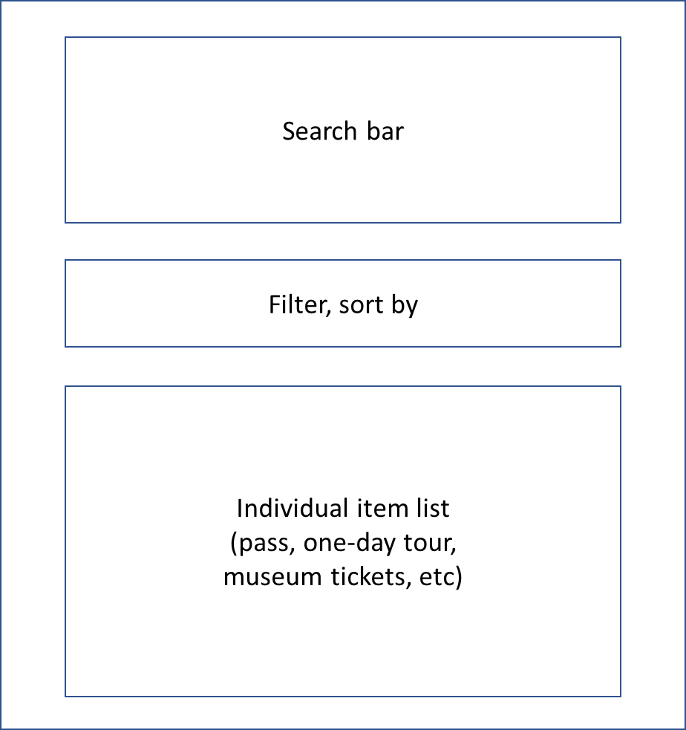Functionality guide:
    - Search function: User can input any keywords in the search bar and then click the search button (e.g. location, price, nights, etc.). The scroller will direct the page to the result once the search button is clicked.
    - Filter function: User can filter the packages by province using the filter blocks. The scroller will direct the page to the result once the search button is clicked. Click show all can show all the packages.
  + Database description: This page doesn’t include PHP functions.
  + Special coding considerations:
    - Auto scroll: We implement the auto scroll function into the buttons to give user a better user experience while they are browsing the page.
    - Responsive page for different devices: When browsing the page in small screen devices, the page will fit in the screen size and reduce the detailed information automatically.
* Contact Us Page
  + Page guide: This page shares the information of the employees and partnerships of the company.
  + A picture containing text

    Description automatically generatedFunctionality guide: This page doesn’t include any Javascript functions.
  + Database description: This page doesn’t include PHP functions.
  + Special coding considerations:
    - Responsive page for different devices: When browsing the page in small screen devices, the page will fit in the screen size.